**Software Development and Testing IT7320**

**LAB WORK**

Team Members: Submitted to:

Anjali Khandelwal Chalinor Baliuag

Kwino

Ralph Saplan

Thanh Huynh

Due Date: Friday 14 August 2015

Contents

1. Understanding Version Control (Anjali)

2. Surveying the GitHub Platform (Kwinno)

3. Creating a Hosted Repository (Thanh)

4. Touring Content Versioning on GitHub (Anjali)

5. Acquiring Repositories Locally (Ralph)

# Understanding Version Control (Anjali)

# Surveying the GitHub Platform (Kwinno)

## Difference between the Git DVCS and GitHub

Git DVCS (Distributed Revision Control System) uses GitBash, a **command-line tool** to connect to your work locally and its working directory is a full-fledged repository with complete history and full version-tracking capabilities, independent of network access or a central server. (Wikipedia, 2015)[1].

While on the other hand Github, is a web based Git repository hosting system which is free and open source used commonly with team collaborating with a project. It is a **web based graphical interface system** and desktop as well as mobile integration. It also provides access control and several collaboration features such as bug tracking, feature requests, task management, and wikis for every project. (Wikipedia, 2015)[2]. Github also provides private account which needed to pay only few people used it. (Wikipedia, 2015). Github use can be used remotely using Gitbash or other application (Netbeans, Eclipse and etc.)

## Access the common project components of daily GitHub interactions

There are many ways to connect a project to Github, one of the way is using Eclipse. First install the Eclipse Mars Java IDE then after install, open eclipse and

* Go to Help menu.
* Click Install New Software.

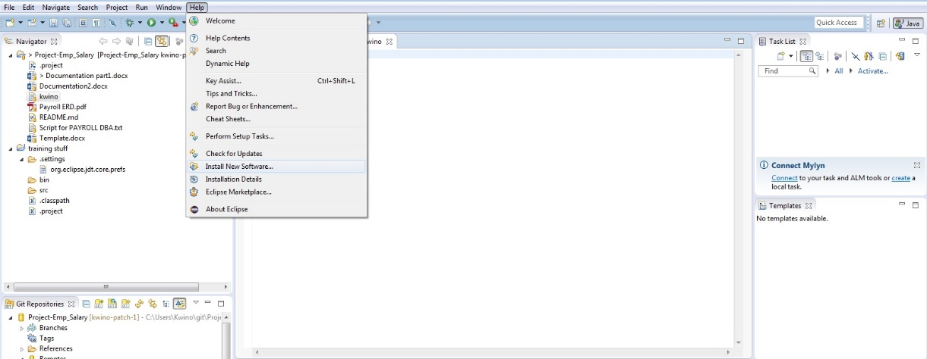

* Choose <http://download.eclipse.org/releases/mars/> to download Github plugin
* Click Collaboration and Install all the Github plugins under Collaboration.

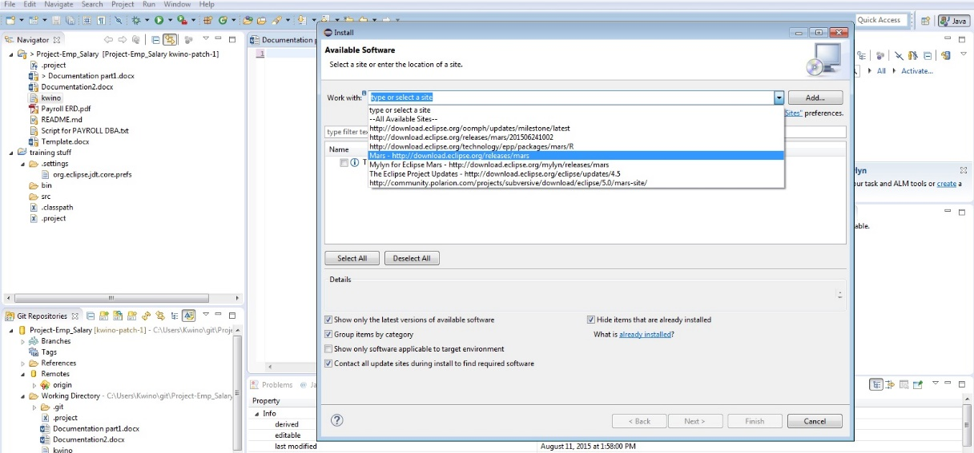

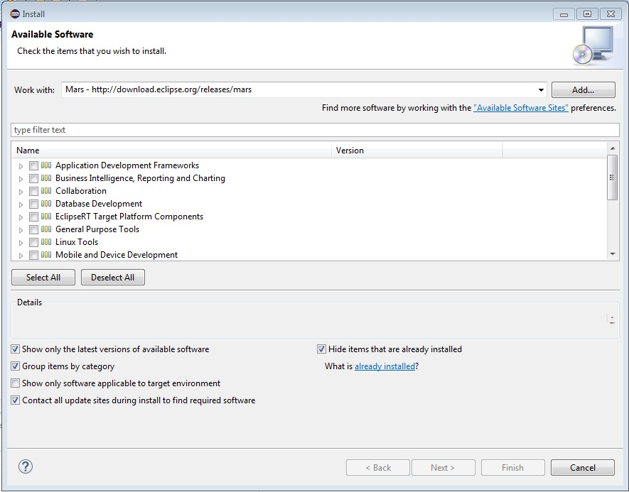

* Then Go To **File Menu** select import and copy the clone in Github paste it in the URI text box. Next is select the repository you want to fetch from Github to your local computer. And select as **Import as general project**.

## Utilize project management components (Issues, Milestones, Collaborators and Teams)

**Issue** is a feature of Github as an integrated bug and enhancement tracker where all the things such as request, suggestion and etc. are being post as message and discuss to the group. In issue you can assign to a specific member and put a label if it is a duplicate, bug, enhancement and others or make your own label.

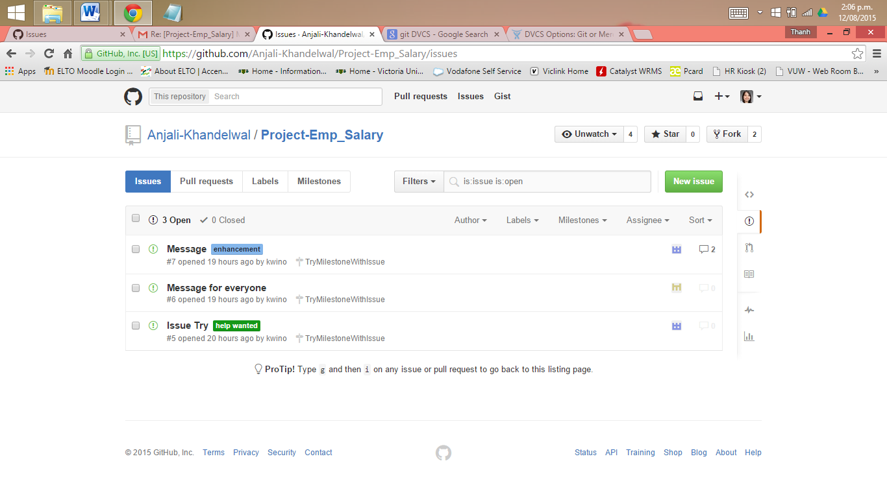

You can create a **Milestone** for your issues and set the due date of your project to monitor. Creating milestone for every project is a great help all issue are being sorted or group by according to what project you are working on and all open, close of issue and completeness of the project were being recorded to display.

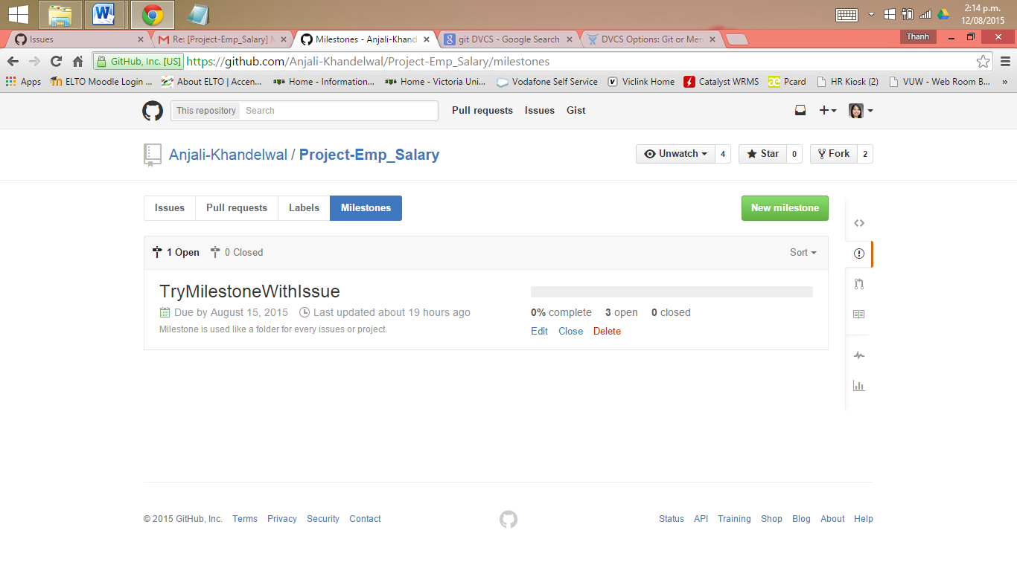

**Collaborators** are users who are assigned to work on a project its either same or different project, under collaborators is a feature called **team** wherein Github are included and group by to work on a same project. The administrator of the team can assigned team members what privileged he/she can use it’s either pull only, push and pull, push, pull and administrative. The administrator of the project can limit the privilege and see the information of the members without their permission.

Github tracker is called **“Issues”** and can be used with every repository and record to report everythings happening inside Github. Issue also

## Recognize best document types for version control (code, CVS/TSV, small binaries)

# Creating a Hosted Repository (Thanh)

## Visit GitHub.com

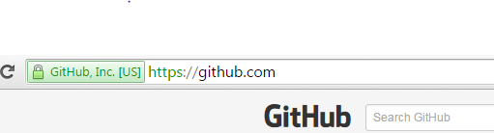

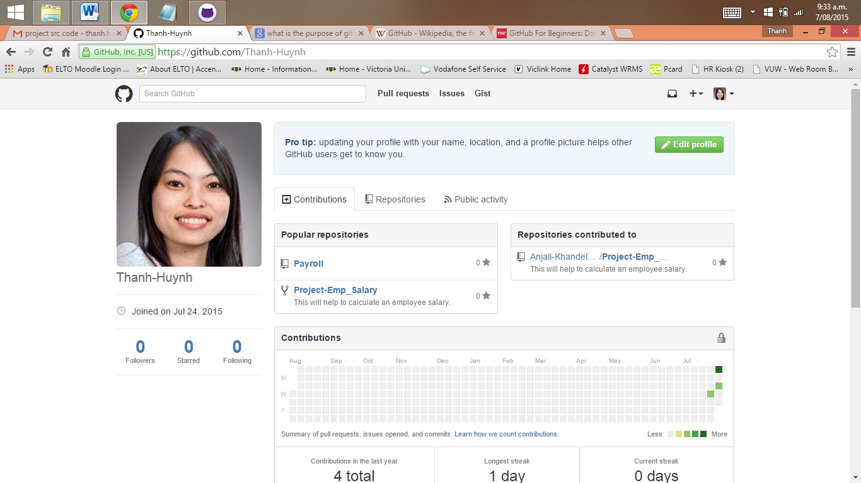

* + Go to the website GitHub.com website
  + Sign up an free account with username (Name to be recognized by team member), email address and password
  + The reason for having a GitHub account:
    - This is free for an unlimited quantity of public repositories.
    - This is a place where we build a profile, upload a project to share connect with the team members by “following” their accounts
    - GitHub can store any type of files like programs, code, text documents and so on in the project folders.
    - It is a public place where everyone can access and see your work. However GitHub does make sure the ownership is well retained. It states in their Term of Service that *“We claim no intellectual property rights over the material you provide to the Service. Your profile and materials uploaded remain yours.”*

## Create a repository and ways to interaction

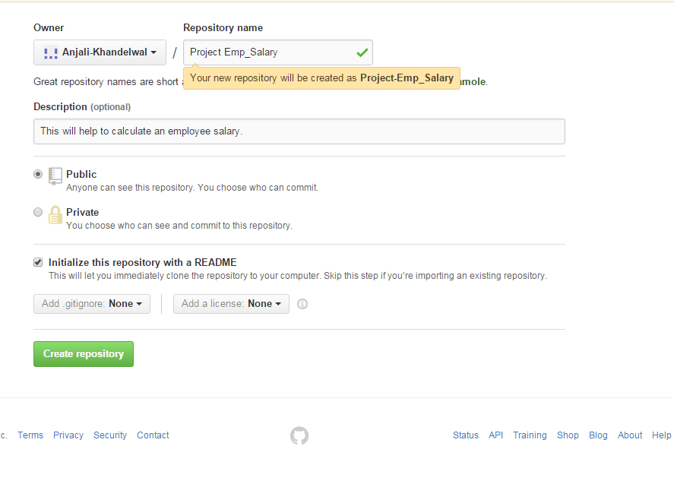**Using GitHub Web user interface**

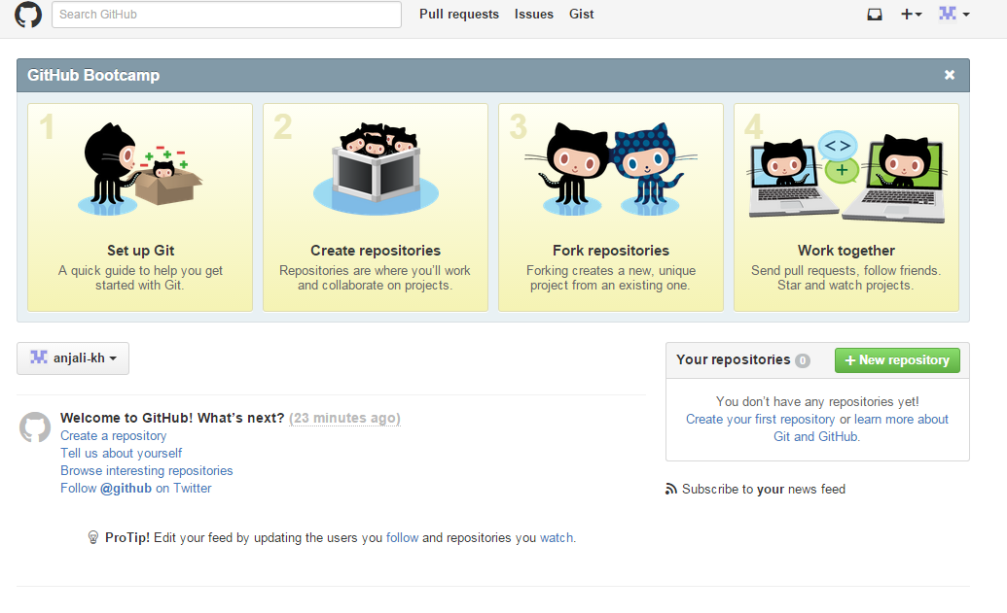

* + Create a short and meaningful name for your project repository. This is to help yourself and your team members to understand and remember. Our repository is **Project-Emp_Salary**
  + Add a description of the project repository: **This will help to calculate an employee salary**
  + Choose public repository because it is free and can be accessed by everyone.
  + Select Initialize this repository with a README
  + Click Create repository. Now we are ready for the first commit

The above is one of the ways to create a repository using GitHub website user interface. There are other ways to create a repository such as:

**Using GitHub GUI**

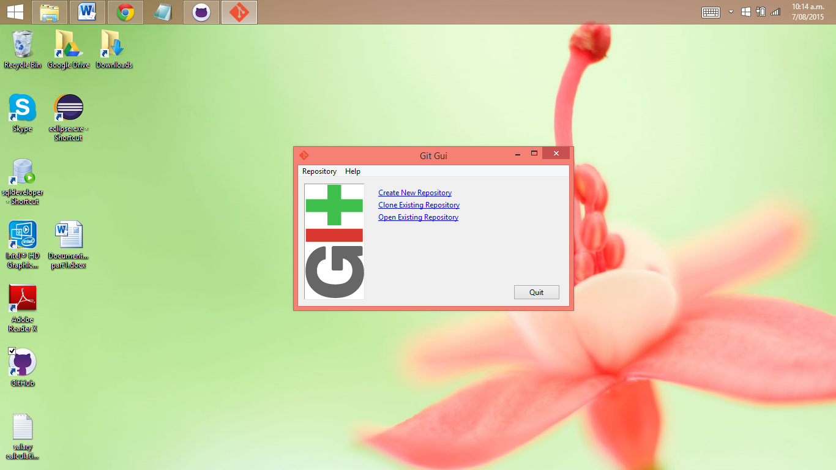

**Using Git init at the command line**

There are two approaches:

1. Takes an existing project or directory and imports it into Git.

We will create a new Git repository skeleton *.git by go to the project’s directory and type”$ git init”.

At this point, nothing in your project is tracked yet. To begin tracking those files and do an initial commit by

$ git add *.c

$ git add README

$ git commit -m 'initial project version'

At this point, you have a Git repository with tracked files and an initial commit.

1. Clones an existing Git repository from another server.

If there is a project you’d like to contribute to — the command you need is “git clone [url]”. This will help Git to copy of all data that the server has.

**Using Eclipse**

Download EGit at <http://www.eclipse.org/egit/download/>

An Eclipse plug-in to use the distributed version control system Git.

The toolbar entries allow you to add an existing local Git repository to the view, clone a Git repository and to create a new Git repository.

There is a recommendation to place your Git repositories outside the Eclipse workspace. This separates your Git repository from any additional meta-data which Eclipse might create.

Once you have added an existing local Git repository (Project-Emp_Salary). It will show under the Git repositories view (as below). A right-click any element in the Git repositories view allows you to perform related Git operations. For example if you right-click on a branch you can “checkout” the branch or delete it.

The Git Staging view is non-modal, you can switch between different repositories or even restart Eclipse without losing a commit message and it allows incremental staging for changes.

Open the Git Staging view via the Window → Show View → Other → Git → Git Staging menu.

Also you can choose any file which has changed and move them into the “Staged Changes” area. To commit the staged changes you write a comment message and select the “Commit”

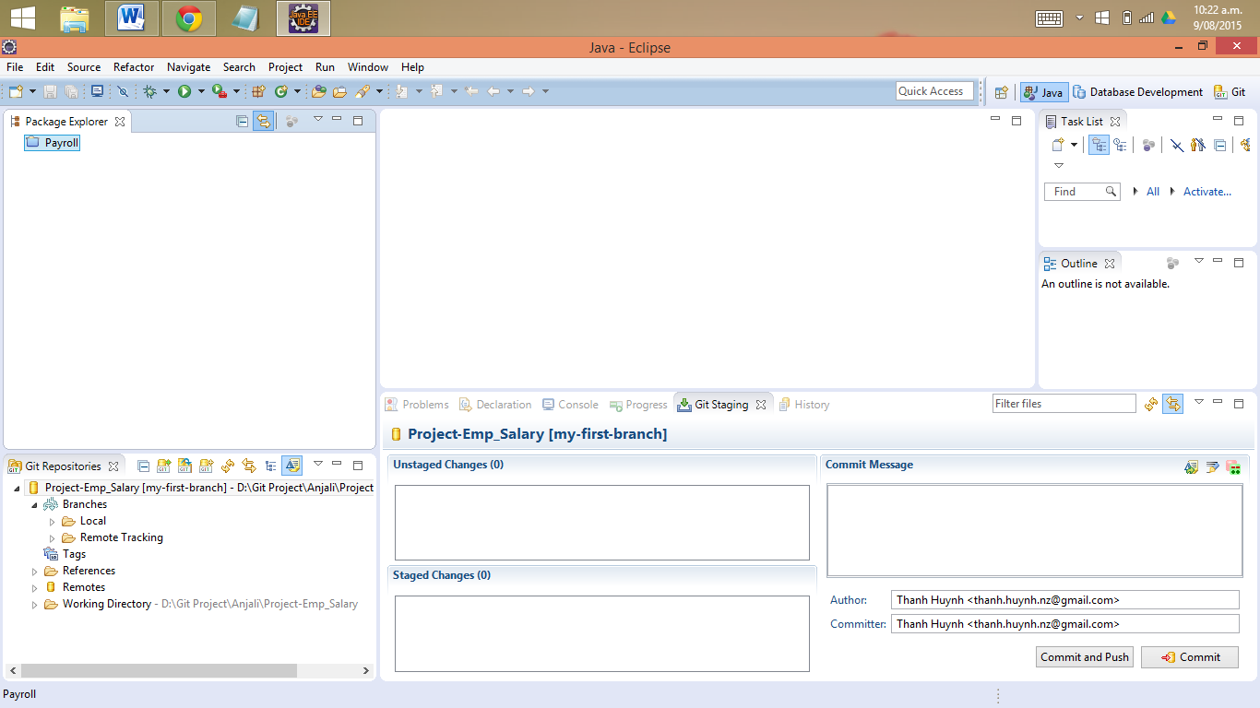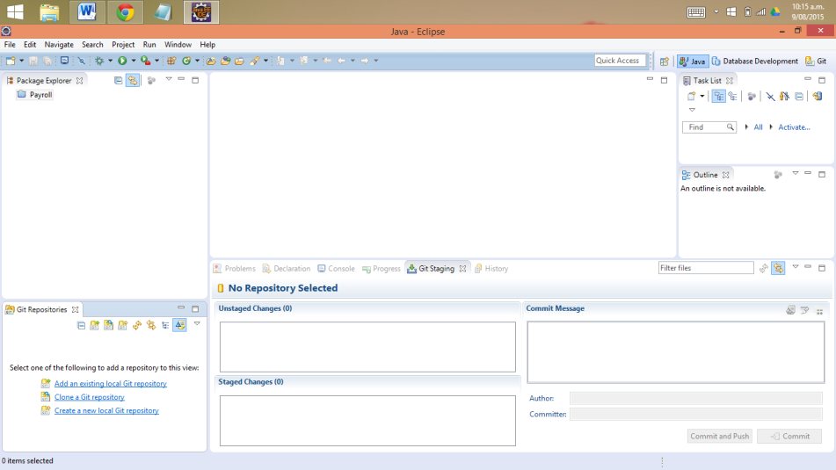

The Git configuration settings can be adjusted via the Eclipse preference setting. Select Window → Preferences → Team → Git → Configuration to see the current configuration and to change it.

You can add entries to your Git configuration by pressing the Add Entries button on the Git Configuration preference page.

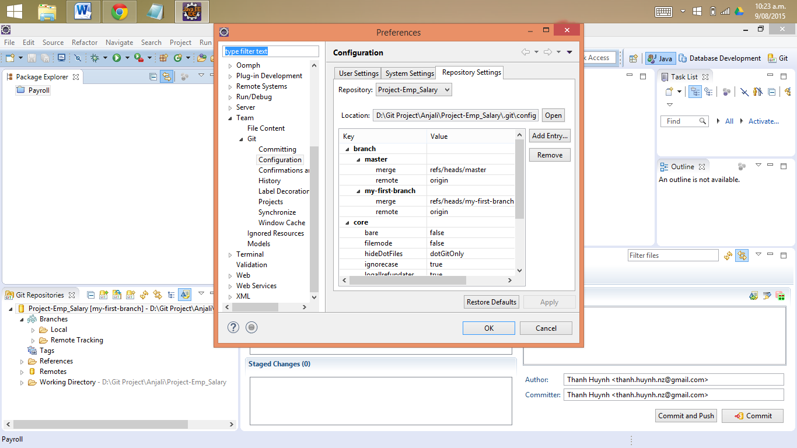

1. Wikipedia (2015). Retrieved from https://en.wikipedia.org/wiki/Git_(software)
2. Wikipedia (2015). Retrieved from https://en.wikipedia.org/wiki/GitHub.